Evaluating the impact of using various biodiesel blends on the performance of diesel engine
Mahmoud, Abu-Zaid
Faculty of Engineering
Mutah University, Jordan

Abstract. Recently, researchers use various types of alternative fuels, for diesel engines. Previous studies, reveals that biodiesel with renewable origin, is the most promising alternative fuel, with less impact on the environment. The objective of this paper, is to determine experimentally, the impact of using different biodiesel blends, extracted from Sun flower, Palm, and Corn oils, on the performance on diesel engine. The engine was operated at variable load and fixed speed. And compare with the results of variable speed and constant load. The following main parameters were determined: Fuel consumption, Brake power, Brake Specific Fuel Consumption (BSFC), Brake thermal efficiency, and Exhaust temperature. Results show that when all the biodiesels were used as a fuel to the engine, the engine has lower BSFC and exhaust temperature, and higher brake thermal efficiency, than when using pure diesel as fuel for the engine. This implies that using the biodiesel blends is more economically than using pure diesel as a fuel for the engine. In addition, it was concluded that using all these blends produces less NO_{x} emissions.
Key words: Diesel engine, Engine performance, Bio diesel fuels, Engine load, Engine speed.

1 Introduction

The transportation sectors usually used a large quantity of crude oil products. The fuel usage in Jordan increases dramatically, with the increase in population. In addition, the prices of crude oil keep increasing. The major resource of fuel for many vehicles is diesel. One way to decrease the diesel fuel consumption is using renewable fuel. For CI engines bio diesel is the most suitable alternative fuel. It produces less harmful emissions, with no sulfur content.
Petroleum products have played a major role in the advancement of technologies and the development of various sectors in the world. The transport sector consumes a large quantity of petroleum products, and plays a major role in the economics of any country. Using blends of bio diesel in the compression ignition (CI) engines can contribute in decreasing the operation costs.
Bio diesel is One of the main sources of renewable energy. Many researchers studied the use of bio diesel derived from animal fats and vegetable oils, in CI engines. Recently, Numerous studies has been performed to use bio diesel blends instead of diesel, to evaluate its effect on the performance of CI engines [1-4}. Puravi and Meiyanathan [5] performed tests on diesel engines using 100% bio diesel alone, he concluded that brake power and thermal efficiency increased significantly. Bhatt et, al. [6[ studied the suitability of mahua oil as alternative fuel for CI engines. They reported that muhau could be easily substituted up to 20% in the diesel without any significant differences in the performance of CI engines.

Puravi and Meiyanathan [7] studied the performance of diesel engines using bio diesel blends, by varying the load and speed. The results shows that with 100% biodiesel blend alone, the brake power, and brake thermal efficiency were significantly increased. Kasundra and Gohi [8] compared different performance parameters of CI engine with different vegetable oils as a fuel.
Nadir et. al. [9] studied the effect of using propanol, n-butanol, and 1-pentanol in waste oil methyl ester (B100) on engine performance and exhaust emissions on a diesel engine running at different loads (0, 3, 6, and 9 KW) with a fixed engine speed (1800 rpm). They concluded that the addition of propane n-butanol, and 1-pentanolto B100 had the effect of increasing brake specific fuel consumption and exhaust gases.
Anbumani and Singh [10] investigated the use of vegetable oils as bio fuel for CI engines. Their study have revealed that among the different vegetable oils, sunflower blend at 15% by volume with diesel fuel exhibited best combustion and performance in terms of total fuel consumption, specific fuel consumption, brake thermal efficiency and cylinder peak pressure. Levent Yaksek et. al [11], concluded in his study, that BSFC is higher for biodiesel blends than pure diesel, he attribute that because the heating values of bio diesel is lower than of pure diesel.
The objective of this study is to evaluate the impact of using different blends of bio diesel derived from: corn, sun flower, and palm oils, on the performance of diesel engine at variable load and constant speed, and compared the results with previous study of the author [12], at variable speed and constant load conditions.

2 Experimental Apparatus and Procedure
A single cylinder diesel engine, four stroke, direct injection, with compression ratio of 17:1, was used in the experiments. The dynamometer maximum speed is 67 rev./sec., with five different engine loads (0, 0.25, 0.5, 0.75, 1.0). The variable speed test is performed at seven different speeds (1200-2400), at an increment of 200 rpm.
The production of bio diesel blends from vegetable oils (Palm, or corn, or Sunflower) was prepared, using sodium hydroxide as alkaline catalyst. The following chemical properties of the blends: Calorific value, Cetane number, and Density were determined.
The engine was started with diesel fuel, and until the engine reached the operating temperature. Then the engine operated using blends of bio diesel with diesel in proportion (20% bio diesel from vegetable oil, and 80% pure diesel).
The following parameters were recorded: instantaneous speed (rpm), fuel consumption, Torque, Exhaust temperature, at variable engine load and fixed engine speed conditions.

3 Analysis

The following formulas were used to determine the value of various parameter in this study:
Brake torque (T_{b}) = Force x radius (N.m) (1)
Brake power (B_{p}) = (2 x π x N x T_{b}) / (60000) (2)
where T_{b} is the brake torque N is r.p.m.
Brake thermal efficiency (η_{bth})= B_{p} /(mass flow rate of fuel x calorific value of the fuel) (3)
Brake specific fuel consumption (B.S.F.C) = mass flow rate of fuel / Brake power (5)
Table 1, shows the main properties of pure diesel, and all bio diesel blends, used in this work. It is clear from the table that the Cetane number, and the heating value, for diesel is the highest, while, the corn biodiesel has the lowest density.
Table 1: Properties of bio diesel from various vegetable oils
Fuel type | Cetane Number | Heating Value KJ/kg | Density gm/cc.
Diesel | 47 | 43400 | 0.855
Bio (corn) | 46.1 | 41867 | 0.846
Bio (Palm) | 46.8 | 41020 | 0.866
Bio (Sun flower) | 46.1 | 41900 | 0.866

4 Results and Discussion
From the collected data during each experiment, torque, mean effective pressure, brake power, fuel consumption, brake specific fuel consumption, brake thermal efficiency, and exhaust temperature, were analyzed, and were plotted versus engine load, to evaluate the performance of the engine as a function of the engine load. The following results were obtained:
The results for the performance of the engine as a function of engine load keeping engine speed constant, the collected data during each set of experiments. The following parameters were determined: torque, mean effective pressure, brake power, fuel consumption, brake specific fuel consumption, brake thermal efficiency. and were plotted versus engine load (min. load, 1/4 load, 1/2 load, 3/4 load, and full load). The results of variables speed test were plotted as a function of engine speed (rpm). The results are as follows:
Figure 1 shows, the fuel consumption rate as a function of engine load. Generally the fuel consumption increase as the engine load, this is because the amount of fuel required is larger, except for diesel which is almost constant at an approximate value of 0.53 gm/s. higher. The values of all bio diesels are lower than pure diesel. This is Because of their lower calorific values compared to pure diesel.
Figure 2, shows the fuel consumption rate as a function of the engine speed . It is clear that the consumption of all blends increases with increasing the speed, The highest consumption is for balm bio diesel, with an average value 0.6 gm/s, the minimum consumption is for corn bio diesel, with an average value of 0.33 gm/s. The reason for lower consumption for corn bio diesel, because of the nearly complete combustion, since oxygen is one constitutes of corn oil .
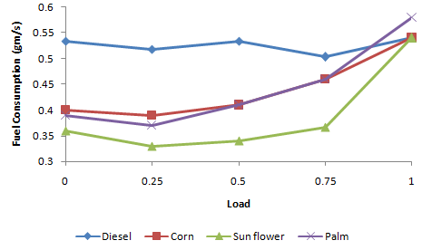
Figure 1: Fuel consumption as a function of engine load

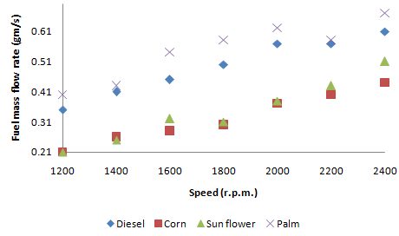
Figure 2: Fuel consumption as a function of engine speed [12]
Figure 3 shows, the brake power as a function of engine load. It is clear that when load increases brake power also increases. The brake power is a function of torque and engine speed. As shown before the torque increases with the engine load, and the speed remains constant. Hence as the engine load increases the brake power increases. The values for pure diesel is the highest. This is because the fuel consumption rate, and is its calorific value is the highest.
Figure 4 shows, Brake power as a function of engine speed. It is clear that the brake power of all bio diesel blends increases with increasing rpm. The brake power of bio diesel of palm is the highest with a value with an average value of 3.9 KW. and the lowest is corn bio diesel with an average value of 3.6 KW. The higher values for palm bio diesel and pure diesel is mainly due to their respective higher heating values, as indicated in table 1.

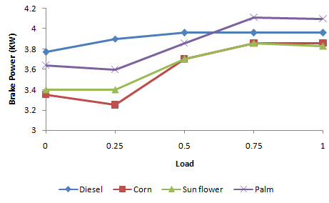
Figure 3: Brake power as a function of engine load

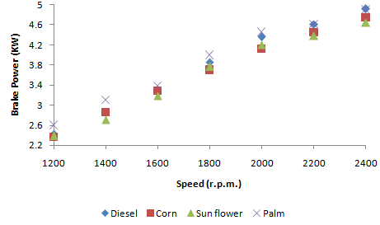
Figure 4: Brake power as a function of engine speed [12]
Figure 5 shows, the brake specific fuel consumption as a function of engine load. This parameter is very important parameter, it shows the capability of the engine to convert the fuel to brake power, which reflects how good the engine performance is. It is clear that with increase in engine load, the BSFC decreases. One possible explanation for this could be due to an increase in brake power with load, as compared with fuel consumption. In addition, once the load reached at full load, the time taken for combustion was decreased, caused incomplete combustion. This shows that using the bio diesel blends is more economically than using pure diesel.
Figure 6 shows, the BSFC as a function of engine speed. It is clear that BSFC is decreasing as the speed increases until an optimum value at 2200 rpm, then increases. The highest value is for Palm, bio diesel, with an average value of 0.13 gm/KW.s and that is because it has the highest fuel consumption. Similarly the lowest value is for corn bio diesel, because it has the lowest fuel consumption. The average decrease in BSFC for palm bio diesel compared to diesel compared to diesel is about 20%.

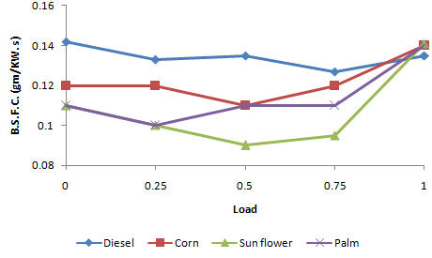
Figure 5: Brake Specific Fuel Consumption as a function of engine load

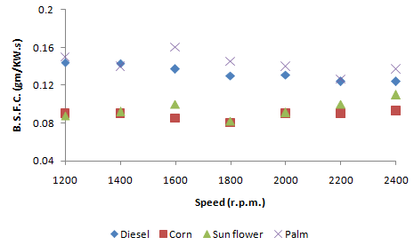
Figure 6: Brake Specific Fuel Consumption as a function of speed [12]

Figure 7 shows, brake thermal efficiency as a function of engine load. The brake thermal efficiency is defined as the ratio of brake power to the thermal energy produced from the combustion of the fuel supplied during the same interval of time. .It is clear, that the brake thermal efficiency increases to about half load, and then decreases. One possible explanation for this could be due to an increase in brake power with load, as compared with fuel consumption. In addition, once the load reached at full load, the time taken for complete combustion was decreased. The values of brake thermal efficiency of all bio diesels are higher than pure diesel. This shows that using the bio diesel blends is more economically than using pure diesel.
Figure 8 shows, the brake thermal efficiency as a function of rpm. The figure shows that the brake thermal efficiency increases with rpm, until optimum value at 1800 rpm. with a value of approx. 30%. This is because with increasing rpm, the output brake power of the engine increases, then the thermal energy decreases after 1800 rpm. Corn bio diesel has the highest efficiency, with an average value of approx. 30% . This is because of higher oxygen content, resulting in more complete combustion, producing higher thermal energy in the engine. Pure diesel has the lowest efficiency, with an average value of 19%.

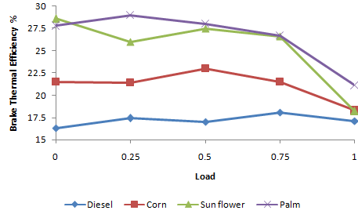
Figure 7: Brake Thermal Efficiency as a function of engine load

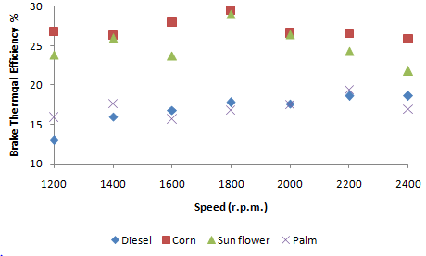
Figure 8: Brake Thermal Efficiency as a function of engine speed [12]
Figure 7 shows, the exhaust temperature as a function of engine load. In general the exhaust temperature increases along with the increase in engine load for all fuels. The increase in exhaust temperature with load is obvious from the fact that more fuel is required to take additional load, which is resulting in producing more thermal energy. Hence increasing the temperature of the products of combustion inside the cylinder.
Figure 8 shows, the exhaust temperature as a function of engine speed. It is clear that as the engine speed increases the exhaust temperature for all blends increases. The engine exhaust temperature has been considered as one of the important parameters . It is a good parameter in analyzing the exhaust emissions especially for NO_{x}. The higher the exhaust temperature, the higher emissions of NO_{x}. The exhaust temperature of all bio diesels are lower than pure diesel. This is because pure diesel has higher heating value than all blends of bio diesel. Thus pure diesel produces NO_{x} emissions more than all blends of bio diesel. The work of McGill et. al [13], confirms that, since they show in their work that the emissions such as NO_{x}, HC, and CO, using bio diesel blends are reduced.

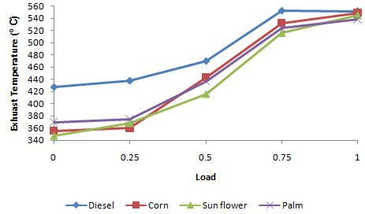
Figure 9: Exhaust temperature as a function of engine load

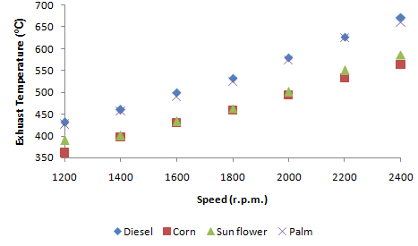
Figure 10: Exhaust temperature as a function of engine speed [12]
5 Conclusions
In this study, a comparison of the performance for a compression ignition engine, using pure diesel and bio diesels fuel blends, at two conditions of variable load and variable speed. The following main parameters were determined: Fuel consumption, Brake power, Brake Specific Fuel Consumption (BSFC), Brake thermal efficiency, and Exhaust temperature. Results show that when all the biodiesels were used as a fuel to the engine, the engine has lower BSFC and exhaust temperature, and higher brake thermal efficiency, than when using pure diesel as fuel for the engine. This implies that using the biodiesel blends is more economically than using pure diesel as a fuel for the engine. In addition, it was concluded that using all these blends produces less NO_{x} emissions. The engine consumes less fuel for corn and sun flower bio diesels than pure diesel. It was concluded that all bio diesel blends have lower BSFC and higher brake thermal efficiency than pure diesel. This implies that using the bio diesel blends is more economically than using pure diesel.

References
- D. Jain, and A. Sharma, , J. Mater. Environ. Sci., 4 (4) pp. 434-447, (2013).
- Z. Khan, A. Saeed, O. Gregory, and A. Ghafoor, Tribology in Industry, Vol. 38, No. 2, pp. 197-213, (2016).
- D. Harreh, A. Saleh, A. Reddy, and S. Hamdan, J. of Eng., Vol. 2018, Article ID 417205, (2018).
- H. Saikiran, and V. Sakthimurugan, , J. of Chem. And Pharmaceutical Science, Special issue 5, (2016).
- K. Puravi, and M. Meiyanathan, Int. J. of Scientific Eng. And applied Sciences, (1),(9), pp. 308-312, (2015).
- G. Bhatt, A. Murthy, and K. Dutta, , J. of Institute of Engineers, Vol. 85, pp. 10-14, (2004).
- K. Puravi, and M. Meiyanathan, Int. J. of Science Eng. and Applied Sciences, Vol. 1, No. 9, (2015).
- L. Kasundra, and Gohil, Int. J. of Eng. Trends and Tech., Vol. 2. No. 2, (2011).
- M. Nadir, J. Erolleri, and Atmanli, , Int. J. of Energy Research. Vol. 40, No. 8, pp. 1134-1143, (2016).
- D. Anbumani, and F. Singh, J. of ARISER, Vol. 5, No.2, pp. 87-97, (2009).
- Levent Yuksek, Hakan Khaleli, Qzener, and Ozogus, FME Transactions, 91-97, (2009).
- Mahmoud Abu-Zaid, Int. J. of Mech. And Production Eng. Vol. 6, Issue 2, (2018).
- McGill, Storey, Wanger, Aakko, Westerholm, Nylund, and Lppi. Int. J. of Fuels and lubricants. Vol. 112, 1456-1473, (2003).

